SPH4U0 Kinematics Review Sample Questions – Day 1

- A train travels 43.0 km [N] on a straight track to Station A and then turns around to travel 15.0 km [S], stopping at station B. The entire trip takes 2.0 hours. Find:
- The average speed over the trip.
- The average velocity over the trip.
- Compare your two answers. Should they be the same? Explain.

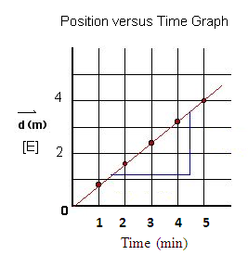
- A position-time graph for an ant on a mission is shown below. Find the ant’s average velocity and sketch a velocity time graph.

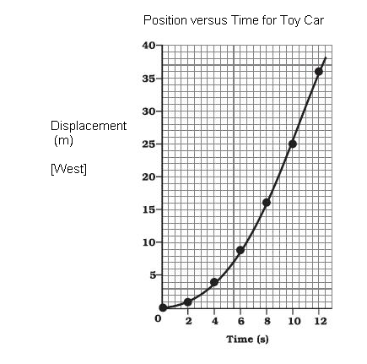

- A position time graph for a toy car starting from rest is shown below.
Find the instantaneous velocities at 2.0, 4.0 and 10.0 seconds.
Sketch a corresponding velocity-time graph.

